Seismic-Safe Building Challenge

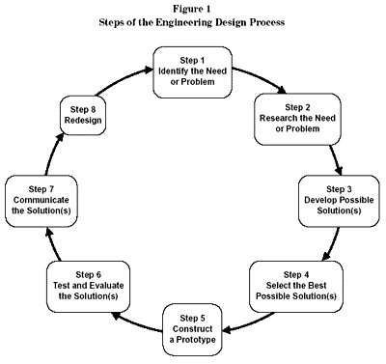

Step 1: Identify the need (challenge)
*You are going to work as a design team for creating a unique seismic-safe building. You will work to design and build a structure that is self-supporting, free-standing, that can withstand a moderate earthquake.

Other thoughts:
- Your grade will be based on your lab work, your notes and design, your completion of questions throughout the lab, a Keynote project, and the performance of the structure.
- The way you work with others will determine if you stay on the team.
- Safety with self, materials, and partners is key! You will be disqualified if you aren’t working safely.
- Stay in your work area, working with your team. Do not disturb other teams.
- You will have “breaks” in construction for reflection and answering questions posed by the teacher.
- You will be asked to collect photos/video clips for a Keynote.

Step 1 (continued): Identify the need (challenge)- Imagine that I am the client that is deciding whether to hire you for construction of my building. What questions do you have for me as your client?

Step 2: Research the Need or Problem- There are already some solutions that designers have found that work to meet this need. Research and find some of the ways we protect buildings. Do this QUIETLY. You are competing with other teams and do NOT want to give away ideas!

Step 2 (continued): Research the Need or Problem- Are there any helpful methods we can get from Nature? Do you know of any plant or animal adaptations that would be worth mimicking in your building? Research.

Step 3: Develop Possible Solutions- Each person on the team must create a design for the building structure. Use your research to guide your design. Label the design with materials and specific structures. THIS IS AN INDIVIDUAL GRADE (15 points)

Step 4: Select the Best Possible Solution- After each person has a COMPLETE diagram with labels, choose the design(s) that your team is going to work with or combine all your ideas into a new sketch. Share your design with me for approval. You must stay within this design. You cannot use another team’s design during the building process! That will disqualify you.

Step 5: Construct the Prototype-
- Assess the building materials.
- Write your checks and purchase materials.
- Build your design.

Step 6: Test and Evaluate the Solutions- You will have an option to test your design on the shake table (for a price). The real tests will occur on one day.

Step 7/8: Communicate the Solutions AND Redesign- You will share your project in a Keynote project. A part of this project will be to create a redesign based on your structure’s performance and other classmates work.

Materials:
Itemized Costs- Beginning Budget of $20,000

Building Materials*
- Regular Size Straws = $100.00 each
- Wooden Craft sticks = $100.00 each
- Small Paper clips = $100.00 for 2
- Cardboard less than 1’ square = $500
- Glue = $100.00 for dime size drop
- Tape = $100.00 for 6 inches
- Glue Gun usage fee $1000/day
- Glue stick = $250/each
- Additional materials TBD

Seismic Testing Cost:
- Small Earthquake Simulation = $500 per test
- Large Earthquake Simulation = $1000 per test

Design Requirements:
Requirement | Description | Disqualification
Height | Between 30-50 cm tall. | Under 30 cm tall.
Area | The area must be between 225 cm²-324 cm². | Your base is smaller/larger than requirement.
Number of floors | There must be at least 4 floors. Each floor has to have a minimum of 5 cm in height. | Less than 4 floors
Function | Top floor will be an open air garage. This top floor must hold 100 grams of mass, even during an earthquake. | Closed garage, unable to support the 100 gram mass
Weight | You cannot exceed 3 pounds. | Over 3 pounds
Furniture/ Appliance | You must have furniture and/or an appliance on each floor. | Not included
Biomimicry | Try to include a lesson learned from Nature. | NONE- just bonus!

Couple of helpful hints:
- Distribution of weight is important!
- Variation in shape can make a difference.
- Foundation materials are key!

Bonus:
- Biomimic integration
- Withstanding a higher magnitude quake
- Flair/overall creativity

Other requirements:

Keynote presentation (complete it as you work/build)

- Slide 1: team member names, the team name & image of the completed building
- Slide 2: What was the problem you were trying to solve?
- Slide 3: What was your companies hypothesis? Must include research on what makes your building design seismically safe – what are the specific design features you are utilizing?
- Slide 4: Designs considered from each team member as well as chosen design
- Slide 5: What materials did you use to build?
- Slide 6: What was your budget? Include a break out of your budget and the total cost of your building.
- Slide 7: What steps did you follow to build your structure? Be specific! Use images as the building is being created.
- Slide 8: Design Specs (height, weight, areas, floors)
- Slide 9: Video of building on shake table
- Slide 10: Concluding slide with results and redesign reflection. What could you do to improve the performance? If you were starting over, what would you do differently?

Things you want to keep in mind as you build to document your progress. You will need these images for your presentation

completed building
designs considered from each team member
team members
budget
video on shake table
different stages of progress
design specs
notes on redesign discussion

    - Results
    - What could you do to improve the performance?
    - If you were starting over, what would you do differently?

