Seismic-Safe Building Challenge

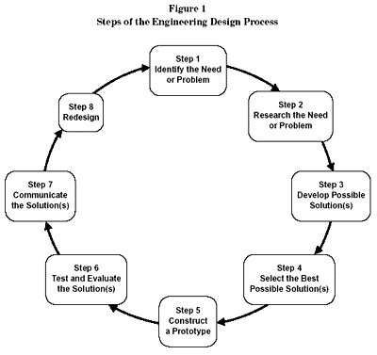

Step 1: Identify the need (challenge)
*You are going to work as a design team for creating a unique seismic-safe building. You will work to design and build a structure that is self-supporting, free-standing, that can withstand a moderate earthquake.

Other thoughts:
- Your grade will be based on your lab work, your notes and design, your completion of questions throughout the lab, a Keynote project, and the performance of the structure.
- The way you work with others will determine if you stay on the team.
- Safety with self, materials, and partners is key! You will be disqualified if you aren’t working safely.
- Stay in your work area, working with your team. Do not disturb other teams.
- You will have “breaks” in construction for reflection and answering questions posed by the teacher.
- You will be asked to collect photos/video clips for a Keynote.

Step 1 (continued): Identify the need (challenge)- Imagine that I am the client that is deciding whether to hire you for construction of my building. What questions do you have for me as your client?

Step 2: Research the Need or Problem- There are already some solutions that designers have found that work to meet this need. Research and find some of the ways we protect buildings. Do this QUIETLY. You are competing with other teams and do NOT want to give away ideas!

Step 2 (continued): Research the Need or Problem- Are there any helpful methods we can get from Nature? Do you know of any plant or animal adaptations that would be worth mimicking in your building? Research.

Step 3: Develop Possible Solutions- Each person on the team must create a design for the building structure. Use your research to guide your design. Label the design with materials and specific structures.

Step 4: Select the Best Possible Solution- After each person has a COMPLETE diagram with labels, choose the design(s) that your team is going to work with. Share your design with me for approval. You must stay within this design. You cannot use another team’s design during the building process! That will disqualify you.

Step 5: Construct the Prototype-
- Assess the building materials.
- Write your checks and purchase materials.
- Build your design.

Step 6: Test and Evaluate the Solutions- You will have an option to test your design on the shake table (for a price). The real tests will occur on one day.

Step 7/8: Communicate the Solutions AND Redesign- You will share your project in a Keynote project. A part of this project will be to create a redesign based on your structure’s performance and other classmates work.

Materials:
Itemized Costs- Beginning Budget of $20,000

Building Materials*
- Regular Size Straws = $100.00 each
- Wooden Craft sticks = $100.00 each
- Small Paper clips = $100.00 for 2
- Cardboard less than 1’ square = $500
- Styrofoam less than 1’ square = $500
- Glue = $100.00 for dime size drop
- Tape = $100.00 for 6 inches
- Spag Noodles = $50.00 each
- Additional materials TBD

Seismic Testing Cost:
- Small Earthquake Simulation = $500 per test
- Large Earthquake Simulation = $1000 per test

Design Requirements:
Requirement | Description | Disqualification
Height | Between 30-50 cm tall. | Under 30 cm tall.
Area | The area must be between 225 cm²-324 cm². | Your base is smaller/larger than requirement.
Number of floors | There must be at least 4 floors. Each floor has to have a minimum of 5 cm in height. | Less than 4 floors
Function | Top floor will be an open air garage. This top floor must hold 100 grams of mass, even during an earthquake. | Closed garage, unable to support the 100 gram mass
Weight | You cannot exceed 3 pounds. | Over 3 pounds
Furniture/ Appliance | You must have furniture and/or an appliance on each floor. | Not included
Monitor | You must include a model of a device that could monitor earthquake movement. (any discussed in class are fine) | No monitoring device model included.
Biomimicry | Try to include a lesson learned from Nature. | NONE- just bonus!

Couple of helpful hints:
- Distribution of weight is important!
- Variation in shape can make a difference.
- Foundation materials are key!

Bonus:
- Biomimic integration
- Withstanding a higher magnitude quake
- Height- tallest in class
- Flair/overall creativity

Other requirements:

- Keynote presentation (complete it as you work/build)

_____ Include a background image of the completed building.

_____ Include a slide with the team members names and the team name.

_____ Include a slide that answers the question: What was the problem you were trying to solve?

_____ Include a slide that answers the question: What was your company’s hypothesis?

_____ Include a slide that answers the question: What materials did you use to build? (Include how much money you spent.)

_____ Include images of your building as it was created. Also, insert images of your notes.

_____ Include a slide of your design specs (height, weight, area, floors)

_____ Include video of building on shake table.

_____ Include a video of your team discussing results and redesign reflection.
    - Results
    - What could you do to improve the performance?
    - If you were starting over, what would you do differently?

