Madagascar Hissing Cockroach
Gromphadorhina portentosa
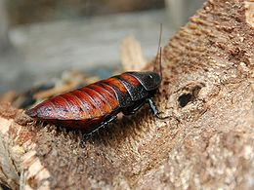
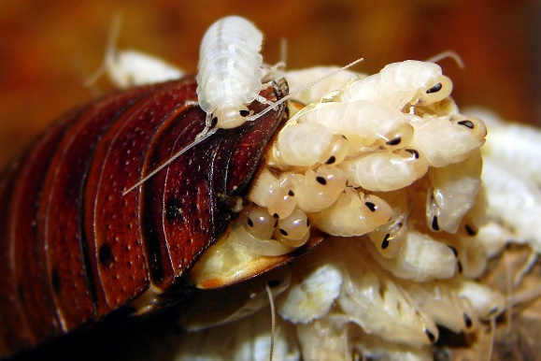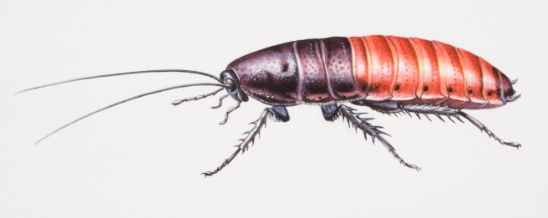

Kingdom: Animalia (animal)
Phylum: Arthropoda (joint foot)
Class: Insecta (cut into sections)
Order: Blattodea (cockroach)
Family: Blaberidae (giant cockroach)
Genus: Gromphadorhina (Madagascar)
Species: portentosa (extraordinary)
Ms.Brown

