Name_______________________________
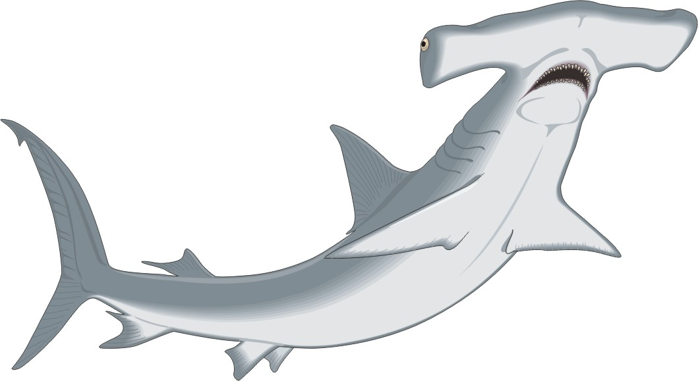
Date______________
Period________________

Interview with a Shark – Student Handout
There are 370 species of sharks. You will be working in pairs to research a specific species of shark and then conducting an interview where one of you will be the shark and the other the interviewer.

Step 1: You will first need to decide which shark you will research. Please sign up for the shark you want from the list below. Every group will be researching a different species so if your number one choice is gone, you will need to choose another species.
Shark Species: Angel, Bamboo, Basking, Cat, Epaulet, Great White, Thresher, Whale, Swell, Dusky, Gray, Leopard, Tiger, Great Blue, Black-Tipped Reef, Mako, Gray Nurse, Cookie Cutter, Hammerhead, Sawfish, Lemon, Night, Bluntnose sixgill, Roughskin Dogfish, Smalltail, Sandbar, Oceanic Whitetip, Bull, Finetooth, Galapagos, Silky, Spinner, Blacknose, Bignose
Step 2: Before starting your research, decide what questions you want to ask your shark. You will need to write your questions out! Include facts about your shark so we know a little bit about that species. Additionally, you must include questions that cover the topics below:
1. | Discuss how each of the shark's five senses function in their search for prey.
2. | Different species of sharks have unique attributes that allow them to survive in their specific habitat. Explain the usefulness of some of the adaptations. Characteristics to consider are the shark's eyes, teeth, diet, body patterns, and tails.
Step 3: Research on the iPads! Find the answers to your questions. You must cite where you got your information.
Step 4: Write a script for the shark and interviewer. You may handwrite this or type it on the iPads. Make sure to introduce your shark and let us know a little bit about them and where they are from and other interesting facts.
Step 5: When it's time to conduct the interview, one partner in each pair should role-play the interviewer and the other, the shark. You may enact your interview live or videotape your interview using iMovie and play them for the class later.
Your grade will be dependent on addressing the topics in step 2! Please make sure you have addressed both topics. Props and visuals are encouraged for your performances.

