Interview with a shark
Name: ________________________________________ Period_____________
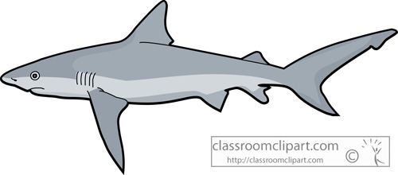

Shark Species:___________________________________________

CATEGORY | 5 | 4 | 3 | 1
Search for Prey  Extra Credit for all five senses addressed | Group researched the subject and integrated 3 or more "tidbits" from their research into their interview. Discuss how each of the shark's five senses function in their search for prey. | Group researched the subject and integrated 2 "tidbits" from their research into their interview. | Group researched the subject and integrated 1 "tidbit" from their research into their interview. | Either no research was done or it was not clear that the group used it in the interview.
Adaptations | Interview explores the usefulness of 1 or more adaptations. Characteristics to consider are the shark's eyes, teeth, diet, body patterns, and tails. |  |  | No adaptations are discussed.
Speaks clearly and audibly | Speaks clearly and distinctly all of the time so that audience can hear and understand interview. | Speaks clearly and distinctly most of the time so that audience can hear most of the interview. | Speaks quietly and audience has trouble hearing the interview. | Does NOT speak clearly and distinctly for audience to hear interview.
Enthusiasm | Facial expression and body language show a strong interest and enthusiasm about the topic throughout the interview, but it is not overdone. | Facial expression and body language show a strong interest and enthusiasm about the topic throughout the interview, but it is somewhat overdone. | Facial expression and body language show some interest and enthusiasm about the topic throughout the interview. | Facial expression and body language depict apathy or boredom with the topic.
Overall Structure and Purpose | Interview establishes a purpose at the beginning and maintains that focus throughout! Cohesive interview. | Establishes a purpose at the beginning, but occasionally wanders from that focus. | The purpose is somewhat clear but many aspects of the interview seem only slightly related. | It was difficult to figure out the purpose of the interview.
Extra Credit | Props and images are used

Total______________/25

