____/8 Step 2: Research the Need or Problem
____/16 Step 3: Develop Possible Solutions
____/12 Step 6: Test and Evaluate the Solutions
____/6 Step 7/8: Communicate the Solutions AND Redesign

____/42 Total

2019 Seismic-Safe Building Challenge
7th grade science final

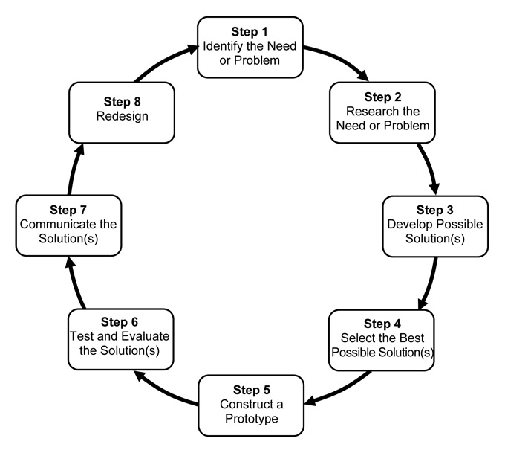

- Your grade will be based on your lab work, your notes and design, your completion of questions throughout the lab, a Keynote presentation, and the performance of the structure.
- The way you work with others will determine if you stay on the team.
- Safety with self, materials, and partners is key! You will be disqualified if you aren’t working safely.
- Stay in your work area, working with your team. Do not disturb other teams.
- You will be asked to collect photos/video clips for a Keynote presentation throughout the entire process.
- All construction must happen during class time – projects may not be brought home.
- This packet is an individual grade and must be filled out by each team member and turned in for credit. This packet is due on Friday, May 24th at the end of class.

Step 1: Identify the need (challenge)
You are going to work as a design team for creating a unique seismic-safe building. You will work to design and build a structure that is self-supporting, free-standing, that can withstand a moderate earthquake.

Step 2: Research the Need or Problem (8 points)
There are already some solutions that designers have found that work to meet this need. Research and find a minimum of four ways that engineers design buildings to be seismically safe. Name the technique and WHY this helps. Do this QUIETLY. You are competing with other teams and do NOT want to give away ideas! Cite your sources!
Technique #1:

Technique #2:

Technique #3:

Technique #4:

Step 3: Develop Possible Solutions- (16 points)
BLUEPRINT! Each person on the team must create a design for the building structure using an 8 ½” x 11” piece of copy paper. Look at the design criteria before you begin your blueprint and the rubric below! Use your research using engineering solutions for seismically safe buildings to guide your design. Label the design with the specific structures from your research. Attach your individual sketch to this packet.

CATEGORY | 4 | 3 | 2 | 1
Information Gathering: What do engineers use to make a building seismically safe? | Accurate information taken from several sources in a systematic manner. Four or more strategies researched and described. | Accurate information taken from a couple of sources in a systematic manner. Three strategies researched and described. | Accurate information taken from a couple of sources but not systematically. Two strategies researched and described. | Information taken from only one source and/or information not accurate. One strategy researched and described.
Plan: How many floors? What are the dimensions of your building? Any special features? | Plan is neat with clear measurements and labeling for all components. | Plan is neat with clear measurements and labeling for most components. | Plan provides clear measurements and labeling for most components. | Plan does not show measurements clearly or is otherwise inadequately labeled.
Scientific Knowledge: Explain why you are using a particular technique | Use of strategies indicate a clear and accurate understanding of scientific principles underlying the construction and modifications. | Use of strategies indicate a relatively accurate understanding of scientific principles underlying the construction and modifications. | Use of strategies indicate relatively accurate understanding of scientific principles underlying the construction and modifications. | Use or no use of strategies do not illustrate much understanding of scientific principles underlying the construction and modifications.
Overall Appearance: Did you use a ruler? | 4 | 3 | 2 | 1

BEGIN GROUP WORK HERE

Step 4: Select the Best Possible Solution- After each person has a COMPLETE diagram with labels, choose the design(s) that your team is going to work with or combine all your ideas into a new sketch. Label this design “Final Design” and share your this with me for approval. You must stay within this design. You cannot use another team’s design during the building process! That will disqualify you.

Step 5: Construct the Prototype- Build a real-life model of your earthquake-resistant structure based on your sketch.

- Assess the building materials.
- Check design specification!
- Look at shake table and how you will attach your building.
- Write your checks and purchase materials.
- Build your design.
Step 6: Test and Evaluate the Solutions- (12 points)
You will have an option to test your design on the shake table (for a price). The real tests will occur on one day.

You will encounter difficulties when working on this engineering design challenge. What were your three biggest problems constructing the earthquake-resistant structure and how did you solve them? Please use complete sentences. You must describe three problems for full credit.

- Problem:

Solution:

- Problem:

Solution:

- Problem:

Solution:
Step 7/8: Communicate the Solutions AND Redesign- (6 points)
You will share your project in a Keynote project. A part of this project will be to propose a redesign based on your structure’s performance.

- Did your earthquake-resistant structure work properly when you tested it? Explain.

- What could you do to your earthquake-resistant structure to improve its performance?

- If you were starting over, what would you do differently? Explain

Design Requirements: (group grade)
Requirement | Description | Disqualification | Points
Height | Between 30-50 cm tall. | Under 30 cm tall | 5
Area | The area of the base must be between 225 cm²-324 cm². DO YOUR MATH! | Your base is smaller/larger than requirement. | 5
Number of floors | There must be at least 4 floors. Each floor has to have a minimum of 5 cm in height. One side must be open to see inside! | Less than 4 floors – all floors enclosed. | 5
Function | Top floor will be an open-air garage (3 points). This means not enclosed! This top floor must hold 100 grams of mass, even during an earthquake (2 points). | Closed garage, unable to support the 100 gram mass | 5
Weight | You cannot exceed 1000 grams | Over 1000 grams | 5
Performance light earthquake | Self supporting and able to withstand light shaking | Building collapses with light shaking | 6
Performance medium earthquake | Self supporting and able to withstand moderate shaking | Building collapses with medium shaking | 4
Performance large earthquake | Self supporting and able to withstand heavy shaking | Bonus
Flair | Creative design or decoration | Bonus
Total Possible |  |  | 35

Couple of helpful hints:
- Distribution of weight is important!
- Variation in shape can make a difference.
- Foundation materials are key!

Bonus:
- Withstanding a higher magnitude quake
- Flair/overall creativity

MATERIALS:

Itemized Costs- Beginning Budget of $5,000

Building Materials*
- Regular Size Straws = $100.00 each
- Wooden Craft sticks = $100.00 each
- Small Paper clips = $100.00 for 2
- Cardboard 30 cm x 30 cm square = $500
- Glue = $100.00 for dime size drop
- MASKING Tape = $100.00 for 6 inches
- Additional materials TBD
- Rubber bands - $100 each
*Bring your own materials TBD cost
NO GLUE GUNS!

Seismic Testing Cost:
- Small Earthquake Simulation = $500 per test
- Large Earthquake Simulation = $1000 per test

FREE: scissors, cardboard cuts by teacher, use of rulers, markers, iPads for research : )

Keynote presentation (complete it as you work/build): (group grade)

Category | Pts. Possible
Slide 1: Include cover slide with image of completed building, team members names, and team name. | 3
Slide 2: Include a statement that answers the question: What was the problem you were trying to solve? | 2
Slide 3: Include a statement that answers the question: What was your company’s hypothesis? Must include research on what makes your building design seismically safe – what specific design features are you utilizing? This slide needs to include the research you did on what engineers use to make a building withstand an earthquake and how you applied this research to your building design. | 10
Slide 4: Include a photograph of the different designs your team considered as well as design that was chosen for project and why. | 2
Slide 5: Include a photograph of the final draft of chosen blueprint and finished structure in a side-by-side comparison. | 2
Slide 6: What was your budget? Include a break out of your budget (list the materials used and how much you spent on them) and the total cost of your building | 5
Slide 7: What steps did you follow to build your structure? (BE SPECIFIC) Include images as building is created. | 2
Slide 8: Include your design specs (height, weight, area, floors) | 2
Slide 9: Include video of building on shake table. | 2
Slide 10: Concluding slide with your results and redesign reflection.  What could you do to improve the performance? If you were starting over, what would you do differently? Sketch out a redesign and label structure/features. | 5
All group members present and presentations are polished | 5
TOTAL | 40
Things you want to keep in mind as you build to document your progress. You will need these images for your presentation so document as you go!

- completed building
- designs considered from each team member
- team members
- budget
- video on shake table
- different stages of progress
- design specs
- notes on redesign discussion – (1) results, (2) what could you do to improve performance, (3) if you were starting over, what would you do differently

Roles:

Sit with your building team. Have your packets out to use as a guideline. Think of how you want to delegate responsibilities –

• Money manager
• Photo documentation specialist (video and stills)
• Building supervisor
• Keynote specialist
• Division of Slides
• Material getter
• Clean up (everyone)

General Rules

- No horseplay
- No wasting materials
- No refunds – buy carefully and in small increments
- No sabotage – ex: gluing down another groups scissors
- Free: scissors, rulers, cuts
- Do not cut cardboard – I will do that for you with electric scissors

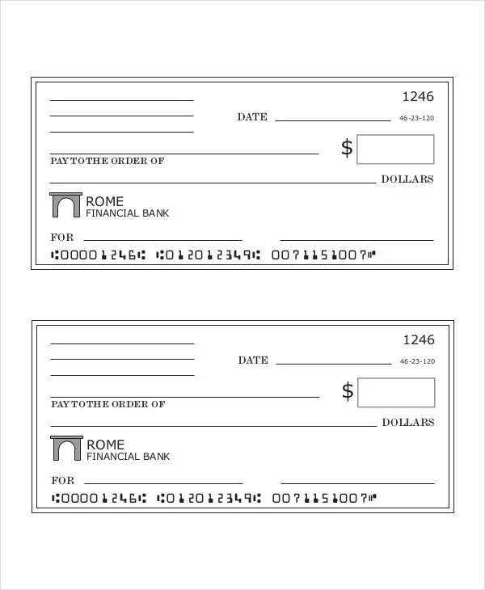
Do Not Cut Out Checks! All Sales are Final. No Returns!

