Name:____________________________________________
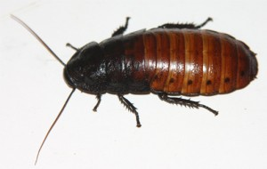
Lab Partner(s):_____________________________________
Period:_____________________

1. What is your research question? Make sure to include a comparison in your question!

2. What is your independent variable (the thing you are changing)?

3. What is your dependent variable (the thing you are measuring)? Is it quantitative? If not, find a way to quantify your observation.

4. How do you think the independent variable will affect the dependent variable? Write a hypothesis stating how you think the independent variable and the dependent variable are related. Format: If (dependent variable) is related to the (independent variable) then (insert your prediction here tying the VI to the DV).

Write your hypothesis here:

5. What are your control variables? Remember in a controlled experiment only one variable is change at a time!

CHECKPOINT #1: GET A STAMP AT HERE BEFORE PROCEEDING

6. What materials do you need? Please list them.

7. PROCEDURE: AWrite up your steps (procedure) for your experiment. Number them and make sure someone can follow these without any other instructions from you and that they will get the same results as you. Make sure you repeat your experiment several times and include this in your procedure.

